Unit test cases result:

1. exact inventory match

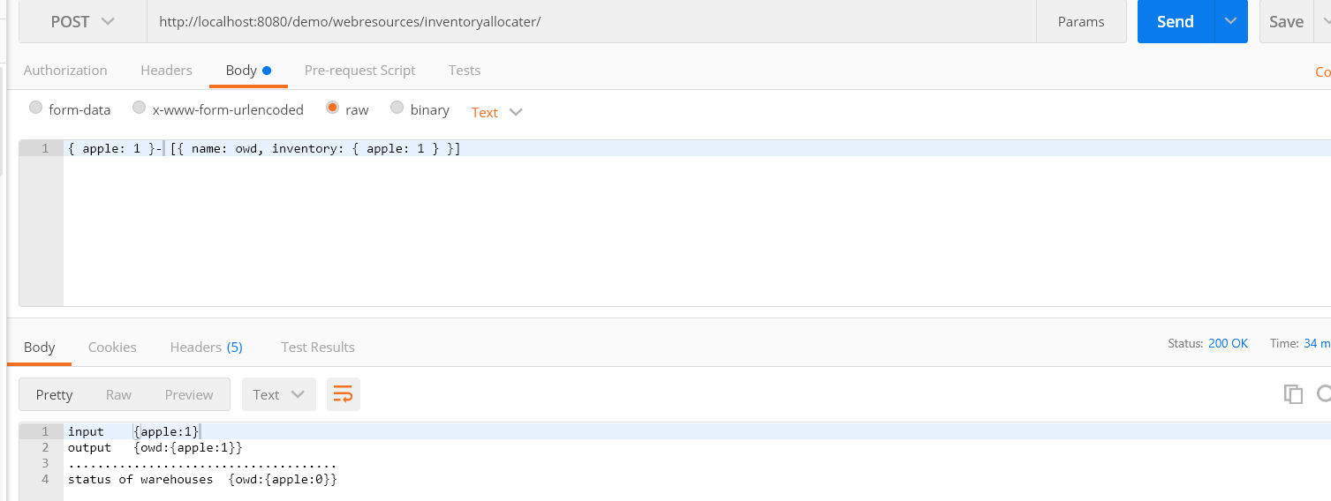

2. Not enough inventory -> no allocations

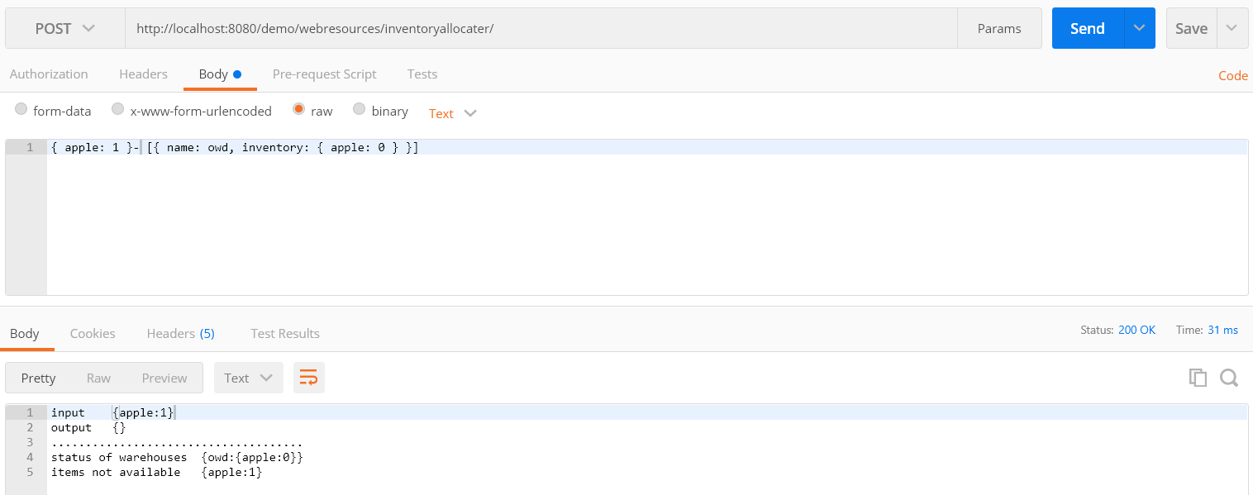

3. Should split an item across warehouses if that is the only way to completely ship an item

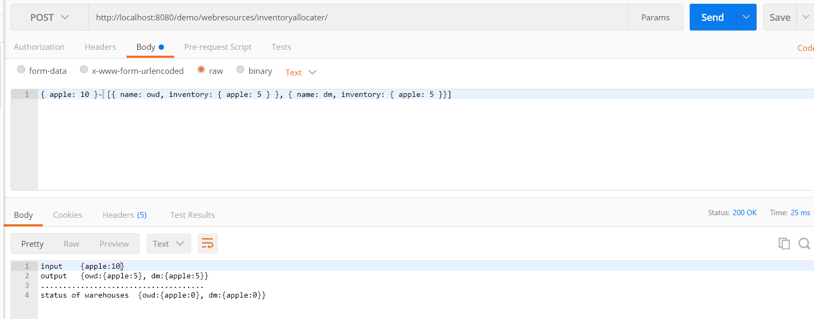

4. order can be completely shipped from one warehouse.

